# **Introduction**

*Have you ever forgotten your phone?*

Chances are you didn’t realize you lost your phone naturally. You never think to yourself, “My phone is missing”. More than likely you reached for your phone in your pocket or your bag and were surprised that it was not there. There is initial confusion when it is not where it is expected to be. Only after processing the confusion and surprise as reality does one reach the conclusion that their phone is indeed missing.

*Have you ever driven home or work by accident?*

Chances are you didn’t rationalize you were driving the wrong way. You couldn't know you were driving the wrong way because you weren't thinking about it. You were supposed to go to a friend’s place or the market and instead wake up having arrived at a common destination (work, home, etc).

These common phenomena are known as **autopilot**.

It’s the reason we

* walk without intentionally moving each individual leg
* live without reminding ourselves to breathe
* eat without focusing on pushing food down our esophagus or through our intestines

# **Low Resolution Efficiency**

Humans are efficient creatures. Thus we autopilot and optimize by operating at the lowest level of resolution all the time; we want enough information to achieve our goal, but more than that is undesirable.

**If we want to make a pizza, we do not need to read a book on coffee.**

What do I mean by low resolution?

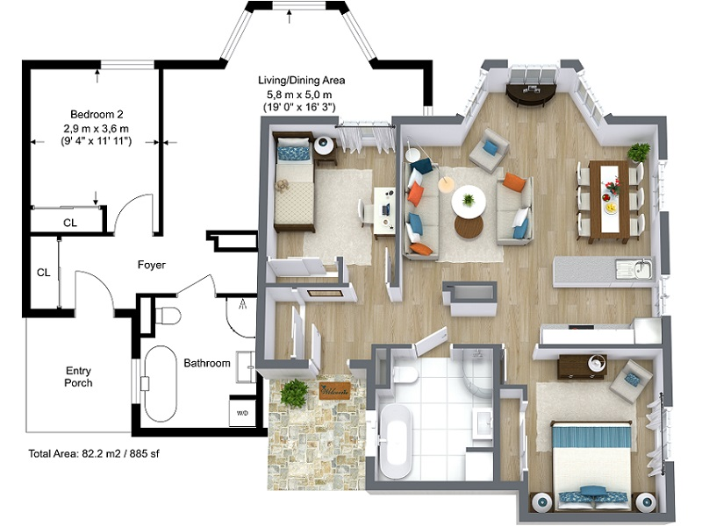

Here are two models of the same space. The left is low resolution and the right model is higher resolution; the left model is a bare floor plan while the right model shows the furnished apartment.

**The low resolution model is a subset of the high resolution model**

That is to say, the high resolution model is the low resolution model with additional details. What this means is we **always** have a low resolution model and only **sometimes** have a higher resolution model.

For example, we **always** have the first story/foundation of a building and only **sometimes** have a third story. We always have the opening of the chess game, but we might not always have an endgame. The ending necessitates the beginning. The child necessitates the parent. We cannot have a third story of a building without the first story.

### What are the implications of Low Resolution Efficiency?

*Q : Given these two models, which is best suited for the simple task of moving from room A to room B?*

A : The left model is most appropriate to know moving from A to B.

The empty floor plan is sufficient to detail how to get from A to B. While it is true that the high resolution floor plan also has these details, it also has additional extraneous details.

**When there are two options that are sufficient, the minimal one is more optimal.**

An example illustrating this principle is when there is a meeting scheduled at 3PM. Arriving at 2PM and 3PM are both sufficient to attend the meeting, however waiting one hour for the proper time to arrive is not optimal.

# **The Problem**

In the introduction we've introduced the phenomena of autopilot. We live as much of our lives on autopilot as possible because operating at a low resolution is optimal. (eg, Arriving at 3PM for the 3PM meeting.)

However, when is a Low Resolution model inaccurate? In the edge cases.

When I was a child I played my first MMORPG, I joined the world without any understanding. I talked to many people and all of them were helpful. They teached me, trained me, and even helped me by giving me beginning materials. As Adam in the Garden of Eden it is impossible to have a conceptualization outside of naivety. People are incredibly friendly and helpful. Until they are not.

I was betrayed and scammed and it was a difficult lesson to learn. By lesson I mean that I had a previously held belief – previously held experiences that ultimately were shown to be inaccurate. Many people are helpful – but not all people.

My model of other player's behavior was inaccurate. If I was never betrayed or scammed there would be no vision to learn. My naive low resolution model would have continued to be successful and autopilot would continue until a break in the abstraction occurred.

# **High Resolution Accuracy**

The problem with a Low Resolution model is in the edge cases. The basic form of learning is starting with a hypothesis and then slowly increasing the resolution to meet the use-case.

Here are some poor examples :

For instance, being aware of chest pain is sufficient to call for help. The friend who arrives and calls the ambulance will interpret the low resolution 'help' and might add details and call it a heart attack. The paramedics who arrive would analyze the situation and come to a more precise diagnosis of the heart condition. Lastly, the doctor who receives the patient and begins surgery will have a complete understanding of the problem, specifically targeting the left ventricle, artery, etc (I'm not familiar with medical).

Perhaps the best example is when navigating to a new location, say a restaurant.

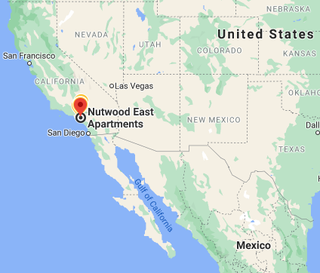

From the car it would be insufficient to know the restaurant's city. Typing in the restaurant's name, our GPS would give us street by street instructions to help us arrive.

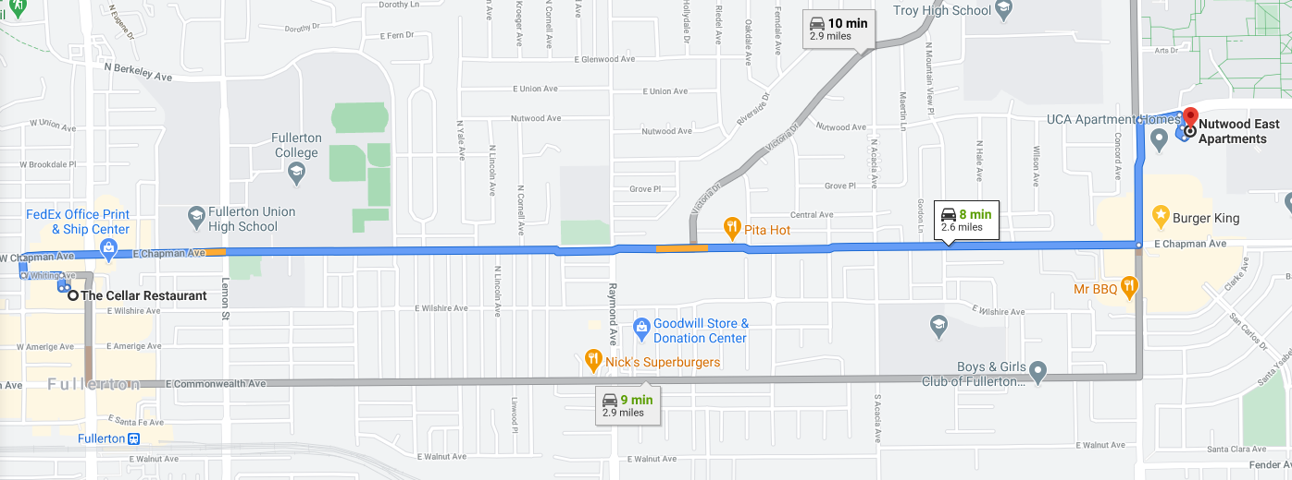

However once we're nearby we actually cannot find the building.

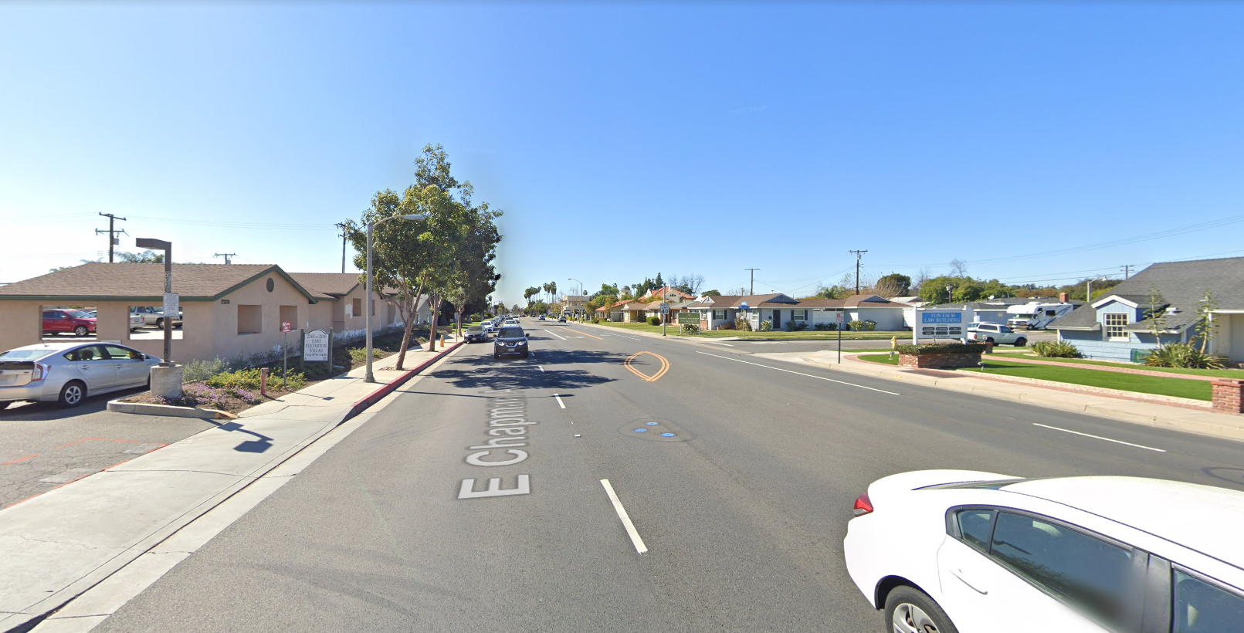

We increase the resolution again to a street-view and are able to find the hidden building.

Another example is imaging a world where only forks exist. Forks are sufficient for all their needs and thus one would never (and could never) conceptualize an alternative. Even the language of 'eating' would imply the fork because they are never divorced – they are equivalent words and thus 'fork' would not even exist as a word/concept because there is no alternative.

And then we encounter soup. The conclusion would NOT be that 'fork' is insufficient and we need an alternative – the conclusion would be that soup cannot be eaten.

And then we come across another who is eating soup with a spoon. Finally our abstraction is broken and we have the opportunity to learn. Soup can be eaten, we were previously mistaken, and the term 'fork' will exist independently from 'food/eating' and also exists to contrast to 'spoon'.

The next time we come across a similar problem we are quicker to resolve the issue – because we are familiar; not familiar with the problem, but rather familiar with the type of problem. We have learnt, higher resolution, and a newfound vision for utensils.

# **Conclusions**

How do we define **learning**?

The increase of resolution from Low Resolution to High Resolution

How do we **learn**?

Awareness that the current model's resolution is not the highest resolution.

How do we become **aware**?

Run into a problem – a problem is when the current level of resolution is not sufficient for the current environmental/situation/circumstance/goal.

A higher resolution model is not inherently better than a lower resolution model.

The curse of higher resolution is being unable to decrease the resolution.

It is a one-way evolution; it is simple to scramble an egg, however it is significantly more impossible to unscramble the egg.

It is impossible to know what one does not know.

It is not trivial to learn something new.

We'll explore this in depth in a future article: ["Why we shouldn't learn new things"](http://google.com)

In the age of information due to the internet, society is evolving to increase granularity. We have higher resolution on commonplace social norms and there are pros and cons.

Increasing the granularity/resolution on ["Everything is a Spectrum"](http://google.com)

Low Resolution is Efficiency/Utility/Conservative

High Resolution is Accuracy/Clarity/Progressive

The beginning of wisdom is to call things by their names.

<https://www.youtube.com/watch?v=ABSYG5w00So>

Matt Duncan - Good Times